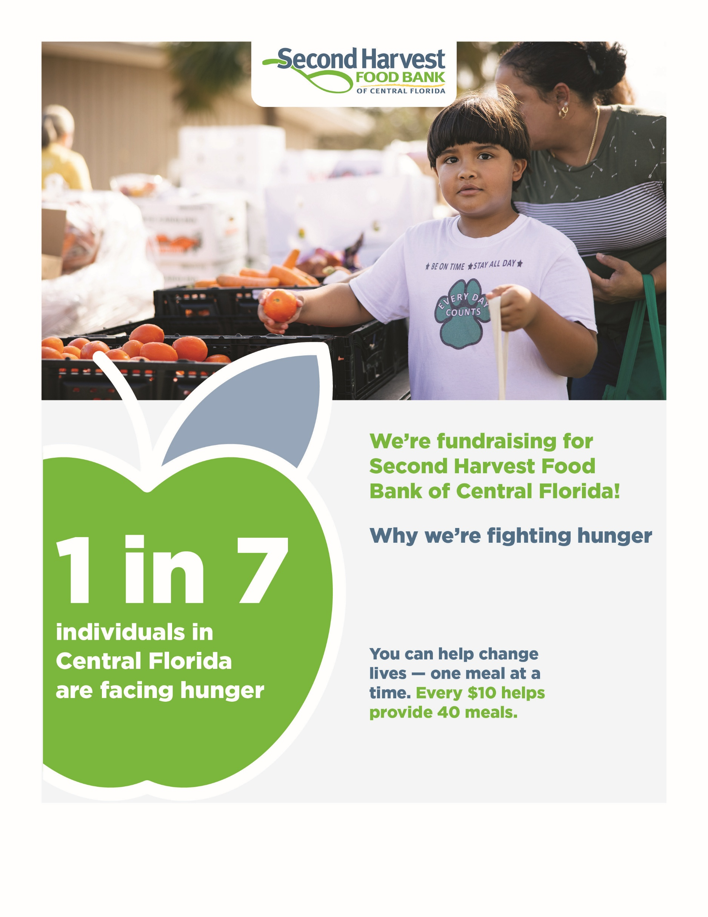
Give now: Add your URL here
Add QR code
Use this space to add your company or group logo and website.
Add your text here

