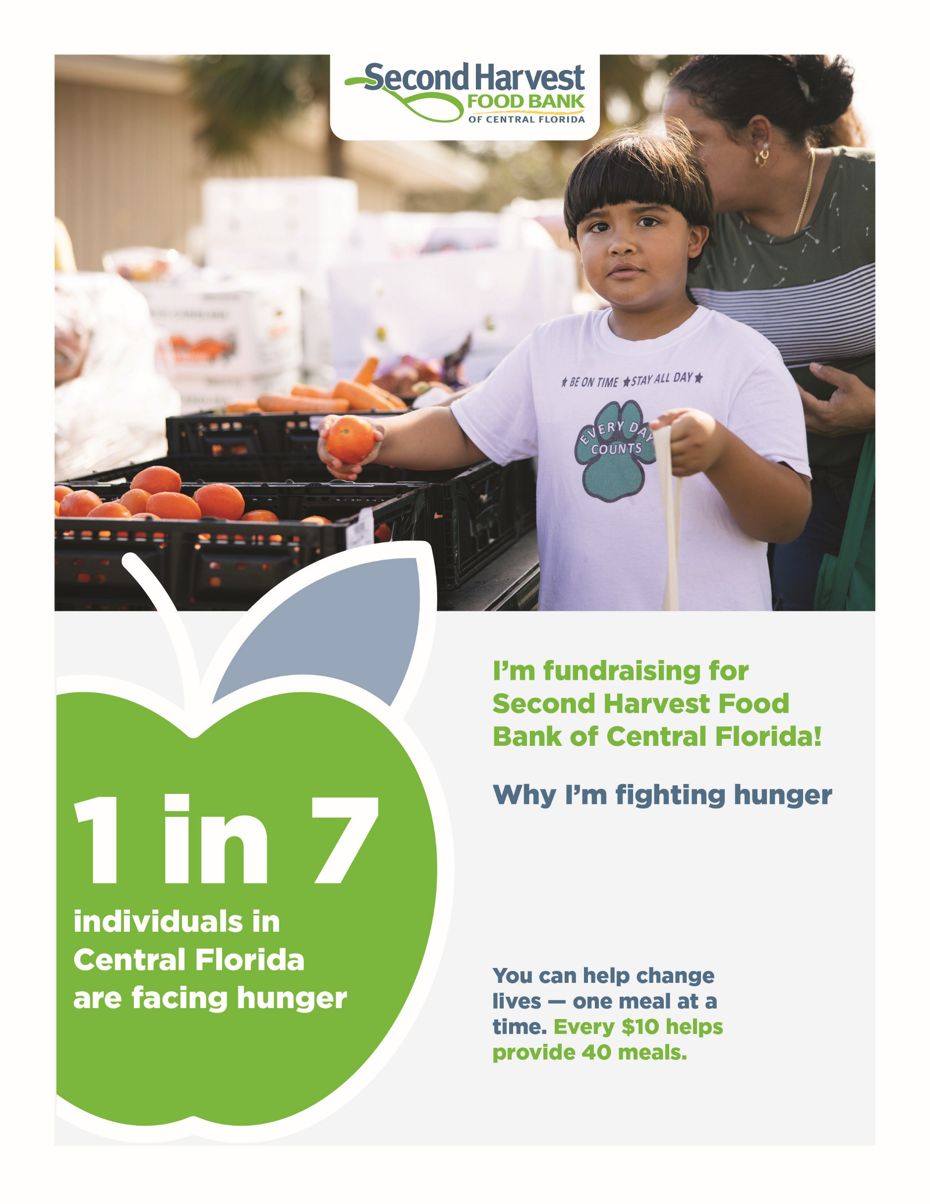
Add QR code
Give now: Add your URL here
Add your text here

